ONLY Pasta cutters in various sizes !

The machine works with electric power
single-phase !

With Electrical Panel Control (Low Voltage )

Structure fully made of stainless steel

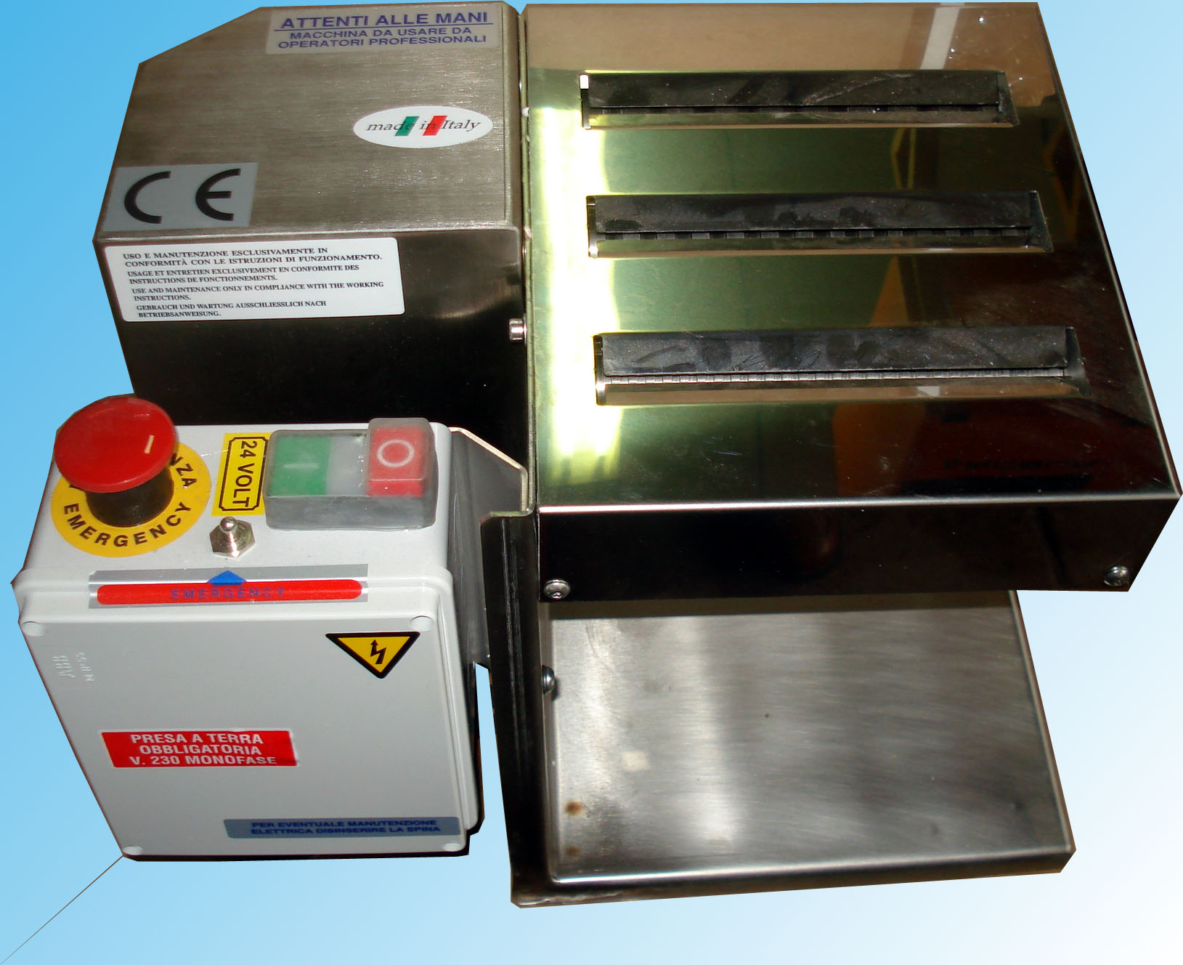

TECHNICAL DATA

USEFULL CUT : 180 mm.
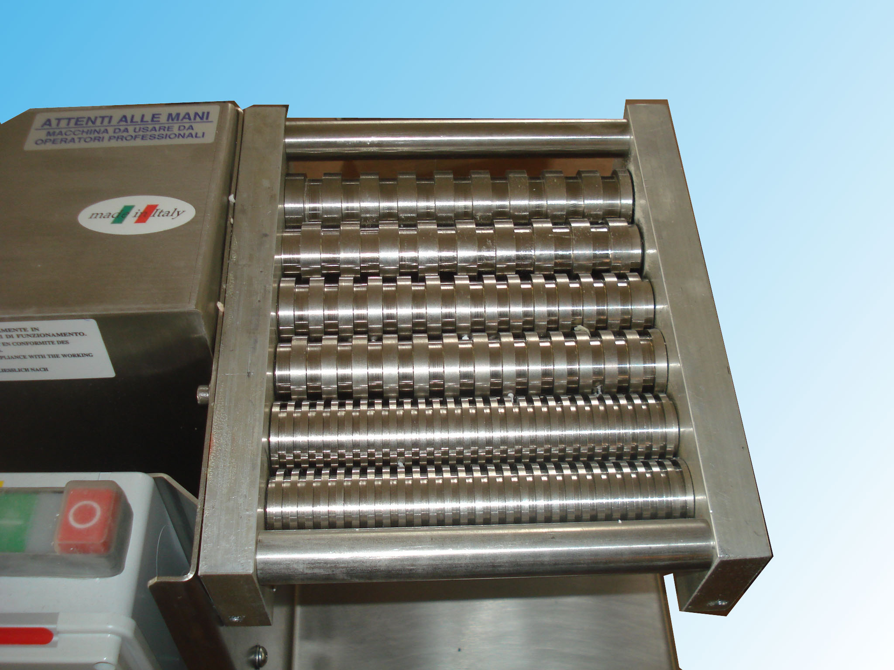

THREE PASTA CUTTERS IN VARIOUS SIZES:
1,6 – 2 – 2/3 – 3 – 4 – 6/7 – 9 – 12/13 – 19 – 24 mm.

POWER : 220 - 230V/1N/50Hz ( single-phase )

DIMENSIONS : 385 x 300 x 254

NET WEIGHT : 18 kg.

